Fruit and Its Color Using Backtracking
AIM:
To write a Prolog program to identify fruits and their colors using facts, rules, and backtracking.
ALGORITHMS:
- Start.
- Define facts associating fruits with their colors.
- Write a rule to retrieve the color of a given fruit.
- Submit a query to identify a fruit and its color.
- Display the first matching fruit-color pair.
- If more solutions are required, request another solution using backtracking.
- Continue until no more matching facts are available.
- Stop.

CODE:
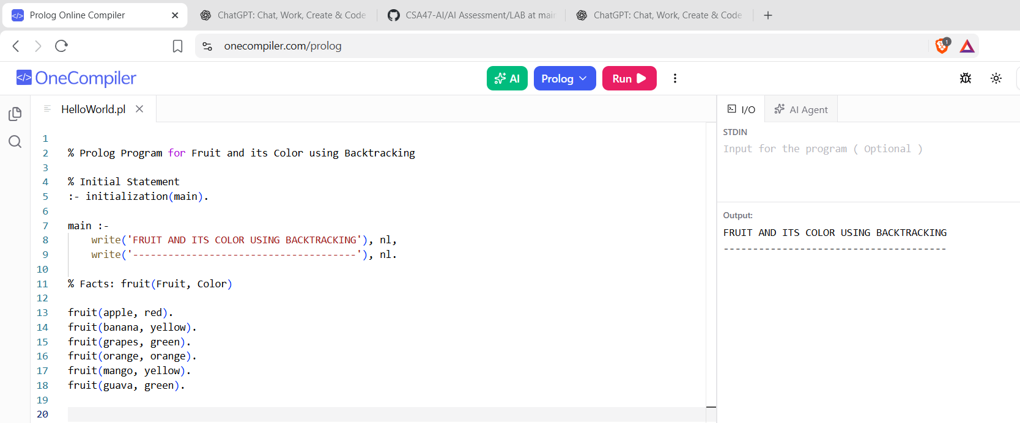

RESULTS:
The program identifies fruits and their corresponding colors using backtracking.

